A Minor Project Final Report on

**2048 GAME USING PYTHON**

Submitted in Partial Fulfillment of the Requirements for

The Degree of

**Bachelor of Engineering in Computer**

Under Pokhara University

Submitted By:

**Harkesh Kathayat, 181312**

**Kushal Acharya, 181317**

**Manjit Shrestha, 181350**

Submitted To:

**Roshan Chitrakar**

**PhD (Information Security)**

**Associate Professor, NCIT**

Date:

20 September 2021

**Department of Computer Engineering**



Balkumari, Lalitpur, Nepal

ACKNOWLEDGEMENT

We would like to express our deepest appreciation to all those who provided us the possibility to complete this project. A special gratitude we give to our project manager, Prof. Dr. Roshan Chitrakar, whose contribution on stimulating suggestion, providing proper guidance and encouragement helped us to co-ordinate our project.

Furthermore, we would also like to acknowledge with much appreciation to Er. Madan Kadariya, Head of Department of Information Technology, for his advice and suggestion about our project.

**Thanking you:**

Harkesh Kathayat, 181312

Kushal Acharya, 181317

Manjit Shrestha, 181350

Abstract

Most of the game available today are realistic and contains more of the space of the storage unit. At first, the games are very addictive to play but after some time the addiction towards the game goes on decreasing. Normally, games are considered as a waste of time. Besides entertainment a reliable, goal-oriented games aim for confidence building, knowledge and vocabulary enhancing, and a platform for testing progress.

For our project, we proposed the development of the simple game with low storage but not boring, can refresh the mind, helps to release stress with the help of fun environment. 2048 is a single player sliding tile puzzle video game written by Italian web developer Gabriele Cirulli. Basically, 2048 presents with a 4×4 grid. When you start the game, there will be two “tiles” on the grid, each displaying the number 2 or 4. You hit the arrow keys on your keyboard to move the tiles around — and also to generate new tiles, which will also be valued at 2 or 4. When two equal tiles collide, they combine to give you one greater tile that displays their sum. The more you do this, obviously, the higher the tiles get and the more crowded the board becomes. Your objective is to reach 2048 before the board fills up.

Keywords: Python, Tkinter for Graphical User Interface, Visual Studio Code

Table of Contents

ACKNOWLEDGEMENT………………………………………..I

ABSTRACT………………………………………………………II

TABLE OF CONTENTS…………………………………………III

LIST OF FIGURES ………………………………………………IV

LIST OF TABLES……………………………………………….IV

INTRODUCTION……………………………………………….1-2

1. PROBLEM STATEMENT…………………………………...1

2. OBJECTIVES………………………………………………...1

3. SIGNIFICANCE OF THE STUDY………………………….2

4. SCOPE AND LIMITATION…………………………………2

LITERATURE STUDY / REVIEW…………………………......3

METHODOLOGY…………..…………………………………...4-6

1.SOFTWARE DEVELOPMENT LIFE CYCLE……………....4

2.TECHNICAL DESCRIPTION………………………………..5

3. TIME AND TASK SCHEDULE……………………………..6

CONCLUSION & RECOMMENDATIONS…………………….7

BIBLIOGRAPHY/ REFERENCES………………………………8

APPENDIX……………………………………………………….9-10

List of Figure

Figure 1: Diagram Representing Methodology

Figure 2: Starting Window

Figure3: Game Over Window

List of Table

Table 1: Task and Time Schedule

Introduction

2048 is a single player sliding tile puzzle video game written by Italian web developer Gabriele Cirulli. Basically, 2048 presents with a 4×4 grid. When you start the game, there will be two “tiles” on the grid, each displaying the number 2 or 4. You hit the arrow keys on your keyboard to move the tiles around — and also to generate new tiles, which will also be valued at 2 or 4. When two equal tiles collide, they combine to give you one greater tile that displays their sum. The more you do this, obviously, the higher the tiles get and the more crowded the board becomes. Your objective is to reach 2048 before the board fills up.

1. Problem Statement

It is a solo player game. In the game 2048, a tile 2 or 4 is generated randomly for a turn.  
For a given configuration of 4x4 tiles you have to tell the number of moves a player has made assuming that a tile of 2 only was generated on every move. There are some problems, that a user may face, given as:

* There are no further levels on this game.
* Users cannot see previous score history.
* It has to be addressed because the way of focusing and the tactics thar are used normally would be improvised.

1. Objectives

The main objective of this project is development of the simple game with low storage but

not boring, can refresh the mind, helps to release stress with the help of fun environment

which:

* Provides new entertaining environment but with old concept.
* Optimize the space in the storage unit.
* Provides fun for the user and also to improve the focus.
* Provides offline mode. For non-internet user the offline mini games are the best for the entertainment purpose.

1. Significance of Study

The study investigates the need of a system software considered as a game played only by intellectuals and individuals with critical thinking abilities. However, the fact is that 2048 game can be played by people of all age groups and mind sets. In spite of the services provided for the users to be able to refresh freely, it has not been able to deliver effective enjoyment to the users. With the study, we encountered some lacking features regarding the games related with the important yet unavailable searches. There is need for a game that can meet up to the user’s needs. While the other games offer only the entertainment and refreshment, we plan to develop a new search interface that will offer the entertainment, knowledge and many other practical things required in daily life.

1. Scope and Limitations

The scope of this project is to provide user to play a virtual game with real. This game will provide the features without having internet connection. With our Game, users will be able to:

* Utilize the free time to play a game.
* offline mode
* Single player mode with computer
* good user interface

This project gives the proper outline of the game that will be updated to the next extend. The project has different objectives to follow. The importance’s of the project are:

* This project aims to provide an entertainment package for all age group
* It makes the proper use of the all-primary components of gaming.
* The importance of gaming increases within us after this game.

Literature Study/ Review

2D games are the games which do not take much space in the storage and do not take much time to be created. They are simple to interact. This doesn’t explore the first-person perspective mode. A lot of detailing is not required, just need to be attractive with less controls.

We used python for this project. Python is a popular programming language. It was created by Guido van Rossum, and released in 1991. It is used for web development (server-side), software development, mathematics, system scripting. Python works on different platforms (Windows, Mac, Linux, Raspberry Pi etc.). Python has a simple syntax similar to the English language and that allows developers to write programs with fewer lines than some other programming languages.

Methodology

1. Software Development Life Cycle

This approach deals with the development of software which centers around the idea of iterative development, where requirements and solutions evolve through collaboration between self-organizing cross-functional team. The diagram below represents methodology which includes various stages like analysis or coming up with idea. The second stage is designing of project which is followed by coding. Coding includes iteration that ends at the end of program helping in implementation and finally the game is tested and executed and required output comes out.

CODING

DESIGN

ANALYSIS

S

|  |
| --- |
| IMPLEMENTATION  TESTING |

ITERATION

**Figure 1: Diagram Representing Methodology**

1. Technical Description

For coding we have used Visual Studio Code.

VS Code

Visual Studio Code is a source-code editor developed by Microsoft for Windows, Linux and macOS. It includes support for debugging, embedded Git control and GitHub, syntax highlighting, intelligent code completion, snippets, and code refactoring. It is highly customizable, allowing users to change the theme, keyboard shortcuts, preferences, and install extensions that add additional functionality. The source code is free and open source and released under the permissive MIT License. The compiled binaries are freeware and free for private or commercial use.

Python

This project is completely Python based project. We choose to use python programming language for this project because we are fashioned by its features. Python is an interpreted high-level general purpose programming language. Its design philosophy emphasizes code readability with its use of significant indentation. Its language constructs as well as its object-oriented approach aim to help programmers write clear, logical code for small and large-scale projects.

TKinter

To build this game we used Tkinter for the graphical user interface, or GUI. Tkinter is a python binding to the Tk toolkit, which is used across many programming language for building GUIs. It is open-source and available under the Python License.

1. Time and Task Schedule

The task to be accomplished will require a long interval of time with proper planning and dedication, interest and enthusiasm and flourishment of creativity. We have designed time schedule as follows:

**Table 1: Task and Time Schedule**

|  |  |
| --- | --- |
| **TASK** | **DURATION** |
| Requirement Analysis and Specification | 4 |
| Undertake Analysis of the System | 5 |
| Designing | 10 |
| Produce Requirement Specifications | 5 |
| Testing and Debugging | 2 |
| Test System Modules | 2 |
| Overall System Test | 5 |
| Develop Documentation | 15 |

Conclusion & Recommendations

This project was started with modest aim with no prior experience in any programming project as this, but ended up in learning many things. 2048 is simple interactive video game. It is extremely user friendly and has the features, which makes simple graphics project.

Video games are a form of media that is often associated with negative health consequences. However, when games are played in moderation and with mindfulness, they are a viable source of stress relief as well as a catalyst for mental health improvement and development of social skills. 2048 itself is a relatively modern form of entertainment. It is engaging and immersive on a level different from that of traditional board games and other forms of entertainment. The player actively contributes to the level of satisfaction he/she attains from this medium and thus is more invested and willing to engage in the elements of this game. The amount of play time is also an important factor in the effects of gaming. Although excessive playtime can have negative consequence, gaming in moderation can be healthy, fun, and educational.

Bibliography/ References

We got initial idea to develop this game through:

1. https://play2048.co/
2. <https://youtu.be/b4XP2IcI-Bg>
3. <https://github.com/kiteco/python-youtube-code/tree/master/AI-plays-2048>

Appendix

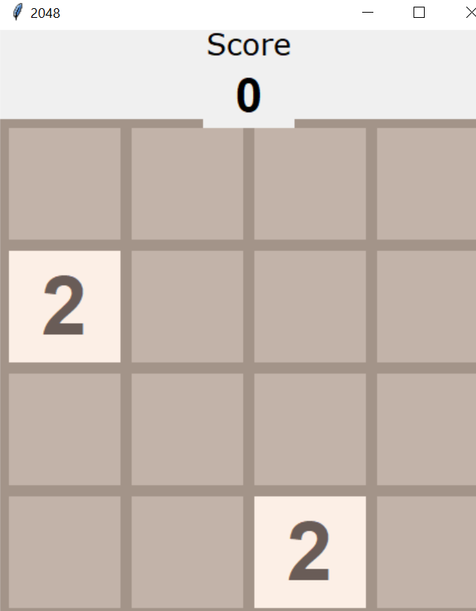

**Figure 2: Starting window**

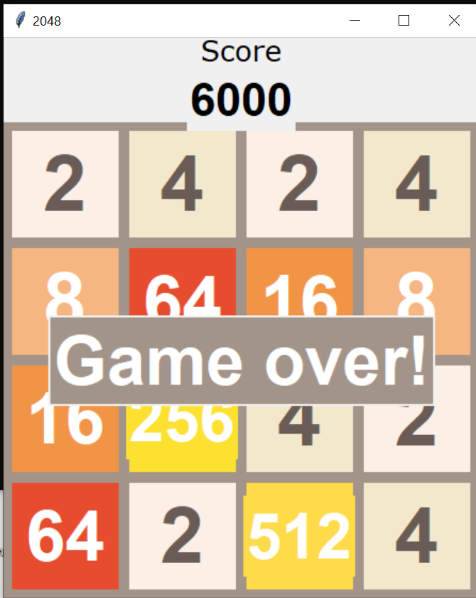

**Figure 3: Game Over Window**